

**George Mason University**

11/29/2022

**Fall**

**2022**

Naman Lahoti

Uma Kotrica

Chandana Marreddy

Lokesh Reddy Mekala

Sahith Battapuram

**DAEN 690**

**Project Report**

**Working on Identification, Characterization, and Analysis of Rotorcraft Flight Maneuvers using Simulated Flight Data**



Table of Contents

Abstract 4

1 Introduction 5

1.1 Background 6

1.2 Problem Space 7

1.3 Research 8

1.4 Solution Space 9

1.5 Project Objectives 10

1.6 Primary User Stories: 10

1.6.1 SIMULATOR QUALIFICATION – QUALIFICATION TEST GUIDE QTG 10

1.6.2 REDUCED ORDER MODELS AND PHYSICS-BASED CORRECTIONS 12

1.7 Product Vision - Sample scenarios 13

1.8 Definition of Terms 14

2 Data Acquisition 16

2.1 Overview 16

2.2 Field Descriptions 18

2.3 Rotorcraft Manoeuvres 22

2.4 Data Conditioning 24

2.4.1 Challenges 24

2.4.2 Additional Data Cleaning Methods 24

2.4.3 Data Extraction Techniques 24

2.4.4 Microsoft Power BI 25

2.5 Data Quality Assessment 26

2.5.1 Completeness 26

2.5.2 Missing Data 27

2.5.3 Uniqueness 27

2.5.4 Accuracy 27

2.5.5 Atomicity 27

2.5.6 Conformity 27

2.6 Other Data Sources 27

3 Analytics, Algorithms, and Visualizations 28

3.1 Location Analysis 28

3.2 Autopilot Mode analysis 29

3.3 Naïve Bayes Classifier 30

3.3.1 Bayes Theorem 30

3.3.2 Gaussian Naïve Bayes Classifier: 32

3.3.3 Gaussian Naïve Bayes Classifier 34

3.4 Random Forest 35

3.4.1 Working 36

3.4.2 Classifier vs Regressor 36

3.4.3 Random Forest Regressor 37

3.4.4 Random Forest Classifier 37

3.5 Logistic Regression 39

3.6 Decision Tree 42

3.7 Conclusion 43

4 Findings and Summary 44

4.1 Recommendations 44

5 Appendices 46

5.1 Appendix – Code and Datasets 46

5.2 Appendix – Agile Development 46

5.3 Project Roles 46

5.4 Appendix – Bibliography 47

# Abstract

To assess the effectiveness of airborne displays in high-density terminal airspace, a thorough set of tests were conducted on a transport cockpit simulation facility. This project's goal is to determine the characteristics that are required to assess the rotorcraft simulation and gather knowledge on how to increase certain variables like endurance and payload limit using the simulated flight data. This would make it possible, even under difficult flying conditions, for the pilot to be aware of the safety precautions during hazardous weather conditions and to have zero failures during flying. The development team has taken the RoAR (Rotorcraft Analysis Recording) simulated data to understand the movement of flight data that represent the engineering units of the individual flight messages. To help FAA better understand their simulation data, the team built a Machine Learning models with over 90% accuracy applying four different types of Machine Learning Models: Naïve Bayes, Random Forest – Regression and Classification, Decision Tree, and Logistic Regression, and generated visualizations based on demographics, and this resulted in new and useful insights with high accuracy.

# Introduction

A rotorcraft is a machine that can fly with the assistance of the air. Two primary fields which manage rotorcraft are aeronautics and aviation. Before a rotorcraft accomplishes its first flight, it needs to go through a series of investigations and testing. The likelihood of any failures ought to be zero. The use of modelling and simulation (M&S) to reduce the amount and associated costs of actual rotorcraft flight testing has been an accepted industry and government practice for many years.

A flight simulator can be used any time of day, in any weather or season. The simulator can be programmed to mimic more difficult flying conditions such as wind or fog, to understand the safety precautions and flight training without the risks associated with hazardous weather in a real helicopter. Before a planned flight, simulators can be designed to practice routes. Each rotorcraft should meet certain criteria such as endurance, flight descent and ascend time, payload, and the length of the rotor blade. There are different types of Rotorcrafts such as warfare copters, and domestic and commercial helicopters.

The various mission profiles and manoeuvres flown by helicopters in-service are the most diverse observed within the aerospace sector, leading to significant challenges when conducting the fatigue design of helicopter components. Variability also exists in the manoeuvres flown by the same helicopter type across different flights and operators. Consequently, the definition of accurate usage spectra is a challenging task and standardized spectra have been used previously to support design efforts, such as the well-established Helix and Felix spectra for helicopter rotor blades. Whilst standardized spectra are typically derived from in-service load monitoring campaigns, there is the ever-present need to validate the usage spectra assumed during component design with the actual usage spectra that a helicopter is exposed to in-service.

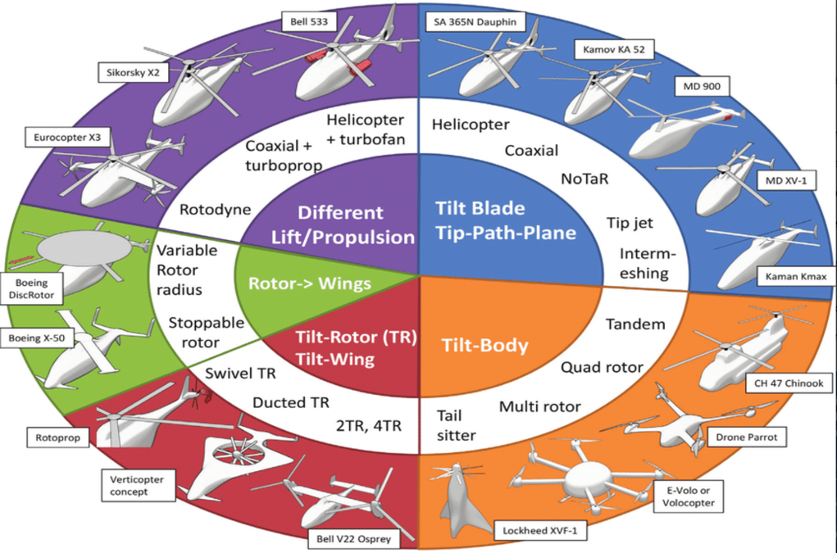

**Figure 1: Different types of Rotorcraft Designs**

## Background

During the simulator qualification process, a set of qualitative tests are also performed by pilots to assess the match between the real helicopter behavior (as known by the pilot) and the simulated one. In many cases, these subjective tests lead to new adjustments to the flight dynamics model. Consequently, this observation brings some evidence that the existing certification objective tests are not sufficient to capture the whole aspect of helicopter flight dynamics. Just as most airplane pilots are taught a certain set of manoeuvres, most of which are required by the FAA Practical Test Standards, helicopter pilots have a set of manoeuvres they are taught. These are broken down into normal and emergency manoeuvres.

These are procedures which are used on almost any flight: Attitude Flying, Basic Hovering, Takeoff and Landing from a Hover, Slope Takeoffs and Landings, Normal Takeoff and Approach, Running Takeoff and Landing, Maximum Performance Takeoff, Steep Approach, Confined Area Approach, Quick Stops (Rapid Decelerations), Cross country flying, Hover out of ground effect (HOGE).

These are general procedures for dealing with emergencies. Every helicopter is different, and the pilot needs to understand the exact emergency method recommended by the helicopter manufacturer in the appropriate POH. These descriptions are meant to deal with emergencies generically and should not be used in a particular model of helicopter. They are: Hovering Autorotation, Tail Rotor failure at a Hover, Autorotation, Precision Autorotation, Ditching, Tail Rotor failure in flight, Engine Fire in flight, Failures like - Alternator Hydraulics and Short Shaft Low side governor and High side governor failures, Runaway Clutch Settling with Power and Low Gee.

Since helicopters have inherently poor handling qualities, analysis of these qualities is of major importance. In recent years a modern set of handling qualities requirements and criteria, ADS33D, has been set up by the US Army. It uses, among other things, so-called Flight Test Manoeuvres (FTMs) for assessing the handling qualities of helicopters [1]. It would be interesting to fly these FTMs with a helicopter simulation program. This would either require a human or a pilot model to ‘fly’ the simulation. The disadvantage of a human is in repeatability. If the human flies the same manoeuvre twice, there will be at best two slightly different manoeuvres. A mathematical pilot model does not have this disadvantage. Moreover, for a human pilot expensive real-time simulation is required, whereas a pilot model can be simulated offline. Such a model will lead to a clearer insight into the execution of manoeuvres by human pilots. Ultimately the model could generate pilot handling qualities ratings. Since cues for determining the different phases in each manoeuvre are essential in the pilot model, this will also allow the fidelity of cues, provided by a flight simulator, to be investigated analytically.

## Problem Space

Aircraft parameter identification is the process of extracting numerical values for the aerodynamic stability and control derivatives, and other subsidiary parameters such as wind gusts, sensors errors, etc., from a set of flight test data (a time history of the flight control inputs and the resulting aircraft response variables). The field of identification has been pursued by diverse interests for many years. The practical application of this work to aircraft flight testing has existed for over 25 years. [2] Despite the wealth of experience which has been accumulated in this period, important requirements still exist for improving the techniques for extracting stability and control derivatives. The main problem statement is to find which characteristics are needed to analyze the simulation of the rotorcraft and gain insights to increase the factors like endurance and payload limit using the simulated flight data [3].

First, there exists today a greater need for stability and control derivatives. There are currently two principal requirements for the mathematical models that these coefficients provide. These are required to provide inputs to simulators, and to provide a basis for the design of flight control systems. A third potential may also exist. Because the stability and control derivatives define a given aircraft more uniquely than the response mode criteria such as those in the Flying Qualities Military Specification MIL-F-8785 there is reason to believe that these parameters will ultimately play more of a major role in the design, testing, and certification of aircraft. Second, with the continuing advances in aircraft design and performance capabilities, the ability to extrapolate wind tunnel test results is diminishing and the importance of flight testing is growing. This is aided by the new Department of Defense policy of building prototype aircraft and thoroughly flight-testing them before a production commitment is made. The principal elements of the aircraft identification process are 1- The identification algorithm, 2-The flight control input and 3- The instrumentation. The ultimate success of the identification process is dependent on all three of these elements, not Just one of them alone.

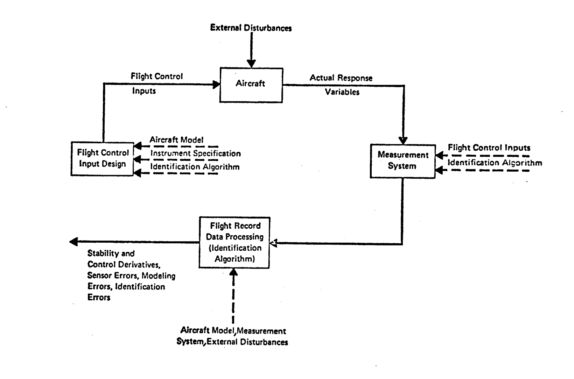

**Figure 2: THE INTEGRATED AIECRAFT IDENTIFICATION PROCESS**

## Research

The goal of the Team's study was to have a thorough understanding of all the factors discussed in the problem statement. The FAA partner provided the Team with information about the Flight Maneuvers during the last few years. Following that, we investigated how rotorcraft design and development necessitates the ability to compute rotor performance and manoeuvre loads. Most of our study concentrated on the analysis of factors that impact the endurance and payload limit of the rotorcraft.

We began looking into the other components of our problem statement when the Team had a baseline understanding of the parameters necessary to analyze the simulation of rotorcraft and the aspects that must be addressed. This involved study on a wide range of flight conditions such as hover, transition, slope, normal and running takeoffs and landings. Actual flight operational data is utilized to calculate characteristics such as cruise segment profiles and speeds in different flight phases (e.g., climb, cruise, and descent). Analyzing these parameters can offer precise rotorcraft performance information in addition to a more accurate fuel burn measurement. This information can be useful in rotorcraft analysis and optimization.

## Solution Space

The main problem statement is to find which characteristics are needed to analyze the simulation of the rotorcraft and gain insights to increase the factors like endurance and payload limit using the simulated flight data. There exists today a greater need for stability and control derivatives. There are currently two principal requirements for the mathematical models that these coefficients provide. These are required to provide inputs to simulators, and to provide a basis for the design of flight control systems.

We are planning to use two algorithms which are HMM and Gaussian Mixture Model.

**Hidden Markov Model**

This analysis exploits pilots’ instrument-crosschecking eye movements within an instrument group related to the vertical-, horizontal-, or airspeed-tracking task. From the pilots’ eye-movement data, the HMM estimates the most likely sequence of underlying tracking tasks that the pilot attended to. HMM analysis is especially useful when some instruments overlap among multiple tracking tasks (e.g., the attitude indicator overlaps among all three tracking tasks) because it can utilize the sequential information from the instrument scanning to compute the likelihood of each of the possible tracking tasks.

The actual pilot eye-movements data collected during ILS approach simulation experiments indicated that some experienced pilots may attend to more than three tasks during flight, with the fourth one being a monitoring task, while some inexperienced pilots may attend to only two, dropping one of the tracking tasks probably due to high workload. The results of another flight simulation experiment demonstrated how the pilots’ attention budgeting among these tasks estimated by HMM analysis, combined with the pilots’ eye-movement statistical results, could enhance a cockpit display format study. The experiments demonstrated what additional insights can be obtained by incorporating HMM analysis into the analysis of pilots’ eye movements.

|  |  |  |  |
| --- | --- | --- | --- |
|  | **Vertical-Tracking Instrument Group** | **Horizontal-Tracking Instrument Group** | **Airspeed-Tracking Instrument Group** |
| **Instruments** | AI (Pitch)  Altimeter  VSI  CDI (Glide Slope) | AI (Bank)  HI  Turn and Slip  CDI (Localizer/ Course) | AI (Pitch)  Power  ASI |

**Table 1: Three instrument groups of each tracking axis**

**Gaussian Mixture Model**

It is used to identify common patterns and detect outliers in flight operations from digital flight data. It is a probabilistic clustering model of flight operations that can incrementally update its clusters based on new data rather than re-cluster all data from scratch. It trains an initial GMM model based on historical offline data. Then, it continuously adapts to new incoming data points via an expectation–maximization (EM) algorithm. To track changes in flight operation patterns, only model parameters need to be saved. The GMM method was tested on three sets of simulation data and two sets of real-world flight data. The results indicate that the incremental learning scheme is effective in dealing with dynamically growing data in-flight data analytics.

## Project Objectives

The all-encompassing target of this study was to measure the crucial connections between rotorcraft size (both weight and aspect) and dealing with characteristics in the basic drift and low-speed flight system. More explicitly, this examination expects to make the connection between gross weight and taking care of characteristics, as well as the association between longitudinal pilot offset from the focal point of gravity and the reasonable disposition changes in the control reaction type. As a subsequent goal, the review investigated the utilization of cutting-edge control modes that exploit the interesting qualities of rotors to further develop dealing with characteristics. The team is expected to have perceived the technical methods and tools that were adjusted to handle the difficulties that surfaced while building the models. Deciding on the number of crashes compared with problems that are cause for the crash in blend with the pattern results will give the FAA accomplice and data that will empower them to change methods. The worth that we aim to provide a mix of meaningful insights and suggestions. The best recipients of this data will be to aircrew and the FAA. By giving a more profound glance at FAA's information, we trust that we will empower them to expect and lessen crash episodes later. The suggestions will help the FAA by smoothing out their information assortment cycle to work with additional proficient examinations later.

## Primary User Stories:

### SIMULATOR QUALIFICATION – QUALIFICATION TEST GUIDE QTG

Rotorcraft training simulators need to give a high-loyalty vivid climate to pilots to get a Level D capability, which is the most significant level of test system capability characterized by the Federal Aviation Administration, [5], and European Aviation Safety Agency (EASA) [6]. They are the administrative specialists liable for the acknowledgement of Full Flight Simulators (FFS) and formalize the passing models and methods required for endorsement for every one of the significant parts of a Level D rotorcraft simulator. A Level D capability process permits the substitution of most of the flight hours expected for a pilot's sort rating or intermittent preparation by simulator hours. A Level D preparation test system is made of many sub-framework models connected with the vehicle elements (flight elements, motors autopilot, and flight controls), vehicles frameworks (flying, ancillaries, and so forth) and simulator vivid signaling climate (movement sound, visual, climate, air terminal climate, and so on.). Every one of these sub-frameworks should meet subjective and quantitative approval measures for the rotorcraft type to meet Level D simulator prerequisites.

Both the FAA and EASA are utilizing a useful presentation standard called Qualification Test Guide (QTG). The QTG is a report intended to survey and approve that the presentation and taking care of characteristics of a test system are inside recommended constraints of those of the rotorcraft and that all pertinent administrative necessities have been met. The QTG incorporates both the rotorcraft flight-test information and simulator information used to help the approval. A flight-test information bundle should contain more than 100 individual occasions to meet the base Level D approval necessities. The passing rules of the numerical model are planned by utilizing 'tolerances' and it incorporates an assessment considering the examination between reference flight-test information and consequences of indistinguishable tests processed on a simulator. Likewise, subjective approval prerequisites include a progression of preparing errands and unusual circumstances that are typically spot-checked during the last evaluation to guarantee that there are no discontinuities between simulated fight regimes. The blend of goal and subjective testing is intended to ensure that the completely incorporated simulator is adequately illustrative of the rotorcraft.

QTG manoeuvres (Figure 3) can be isolated into three test classifications: snapshot tests, dynamics tests, and trajectories tests. Snapshot tests are involved when a consistent state condition exists in the flight-test information now caught. dynamics tests include a pre-characterized control input perturbation at a trim condition. trajectories tests are profoundly non-straight maneuvers that will go through different flight systems.

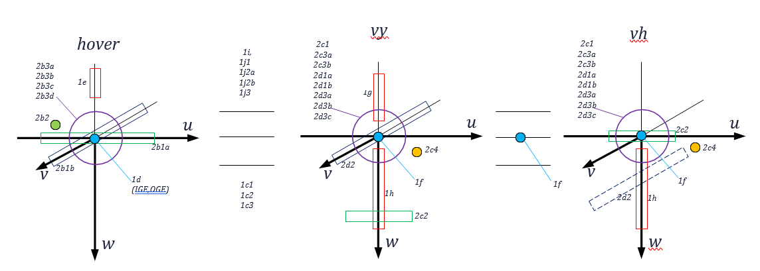

***Figure 3: Distribution of QTG Throughout the Flight Envelope.***

### REDUCED ORDER MODELS AND PHYSICS-BASED CORRECTIONS

Although remarkable progress has been made in growing high-devotion strategies for the further developed expectation of rotorcraft optimal design, for example, CFD, direct utilization of such techniques in flight recreation is restricted by the high computational speed expected for constant flight reenactment. Decreased request models can be removed from high-devotion models while giving proficient calculations. Appropriately inferred decreased request models with material physics-based rectification of the displaying boundaries can hold the reproduction precision required for both designing and continuous flight recreation; subsequently, this gives a viable and powerful method for meeting the prerequisites for both expectation exactness and computational effectiveness. This segment covers various demonstrating viewpoints, including rotor-initiated inflow elements, streamlined obstruction, fuselage optimal design, motor/drivetrain elements with rotor lead-slack elements, and sensor and swashplate actuator elements. The accompanying sub-areas portray every one of the researched material physics-based diminished request demonstrating techniques.

The rotor prompted inflow model is a crucial piece of exact rotor streamlined features and elements displaying that affect flight reenactment in different ways, including, performance, stability, and control reaction. Pitt and Peters and Peters and He [7] inflow models are broadly utilized in the latest flight simulations. Both inflow models just address rotor self-incited actuated inflow over the rotor plane; hence, they come up short on the capacity for anticipating rotor impedance on different rotors and streamlined surfaces. Both inflow models also assume rigid rotor wake geometry, and hence, are limited for modelling the effect of rotor wake distortion that occurs in manoeuvring flight. This leads to an erroneous prediction of the off-axis response of single main rotor helicopters in hover and low-speed flights.

Rotor wake distortion resulting from rotor Tip-Path-Plane (TPP) rotation in manoeuvring flight was found to be a cause of erroneous prediction of off-axis response of single main rotor helicopter in hover and low-speed flight [4]. As shown in Figure 4, the rotor wake experiences noticeable distortion of curvature along with compression on one side while expansion on the other during rotor TPP pitch or roll rotation. The distorted manoeuvring wake leads to a significant change in rotor-induced inflow. The distorted manoeuvring wake leads to a significant change in rotor-induced inflow.

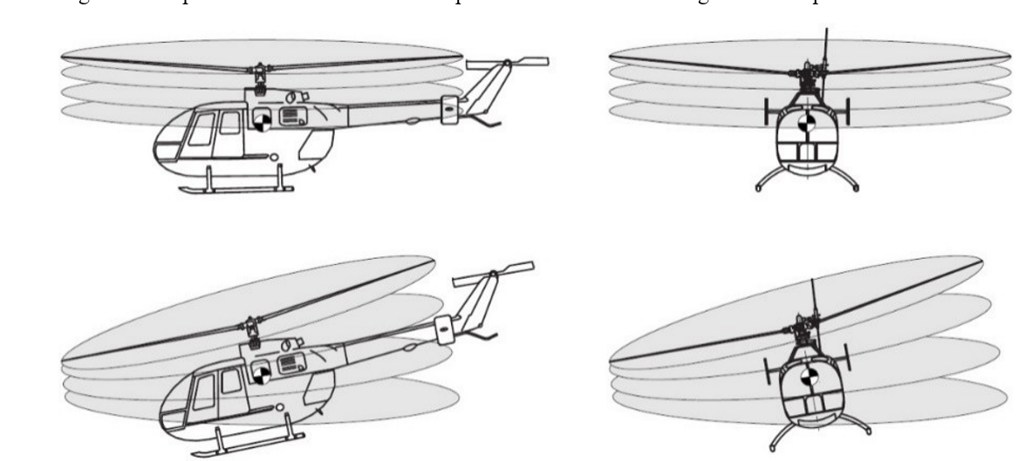

***Figure 4: Rotor Wake Distortion Due to TPP Rotation***

## Product Vision - Sample scenarios

From the Primary User stories above the team determined that the following capabilities outline the user’s objective for the project.

As a User, I want to identify different characteristics of Rotorcraft simulations such as Barometer altitude, pitch, roll, yaw and as well as the latitudinal and longitudinal coordinates which play a major factor in a rotorcraft simulation

As a user, I would also try to understand the temperature of the engines, Torque, Oil pressure, fuel low rate and different cyclic position pitches.

The team was led in several ways by the abilities mentioned above. They first helped the team identify which further datasets would be needed to finish the research. Second, the team was able to clean and filter the appropriate data by quickly determining which properties in each dataset were most important to the research. The team's choice of algorithms and analysis was then greatly aided by the capabilities. Because it was crucial to establish these skills before beginning the analysis, the process of analyzing the data was considerably more simplified and effective.

We believe that using data science tools and methodologies to analyze the data will produce unique insights that will give the FAA and its rotorcraft simulation partners crucial knowledge to aid in their work. Specifically:

*For*: FAA and Rotorcraft Manoeuvre simulation

*Who*: Need to understand different simulation characteristics of Rotorcraft

*The*: Analysis of Rotorcraft Flight Manoeuvre using Simulation techniques

*Is a*: characteristic of Rotorcraft Flight details and different simulation methods

*That*: will help provide insight into the existing data through application of analytical techniques and allow the FAA and Rotorcraft Simulation team to understand several simulation techniques which are beneficial for FAA using the Rotorcraft characteristics

Scenario #1

Several models are typically utilized within single research because no one model can satisfy all demands. This method, which only exchanges static data, works well when applying models in order. For instance, if a scenario has been modeled using a rapid time simulator and contains sector, flight, and route information in electronic format, the data does not need to be collected again to simulate in a real-time environment. To work with the real-time system, it might be altered or reorganized.

Scenario #2

Based on a location (airport/city), date (day of week, time of day), and weather, predict if are certain different manoeuvres which might be helpful and what would be the effect on the attributes such as engine temperature, Oil pressure, weight of the helicopter if there would be a change in the weather.

## Definition of Terms

| **Term** | **Definition** |
| --- | --- |
| M&S | Modeling and simulation are the use of models as a basis for simulations to develop data utilized for managerial or technical decision making. In the computer application of modeling and simulation a computer is used to build a mathematical model which contains key parameters of the physical model. |
| HOGE | The situation in which a helicopter is hovering sufficiently close to the ground to achieve added lift because of "ground cushion." |
| POH | A document published by the airframe manufacturer and approved by the FAA that lists the operating conditions for a particular model of aircraft. |
| FTM | Aircraft rotates about its longitudinal axis without changing direction or losing altitude. |
| FAA | The Federal Aviation Administration is the largest transportation agency of the U.S. government and regulates all aspects of civil aviation in the country as well as over surrounding international waters. |
| HMM | A hidden Markov model is a statistical Markov model in which the system being modeled is assumed to be a Markov process — call it X — with unobservable states. As part of the definition, HMM requires that there be an observable process Y whose outcomes are "influenced" by the outcomes of X in a known way. |
| QTG | Qualification test guide (QTG)' means a document designed to demonstrate that the. performance and handling qualities of an FSTD are within prescribed limits with those of. the aircraft, class of airplane or type of helicopter and that all applicable requirements. |
| TPP | The tip-path plane is the imaginary circular plane outlined by the rotor blade tips in making a cycle of rotation. Figure 9 (right) - The total lift-thrust force acts perpendicular to the rotor disc or tip-path plane. |
| EASA | The European Union Aviation Safety Agency is an agency of the European Union with responsibility for civil aviation safety. It carries out certification, regulation and standardization and performs investigation and monitoring |
| FFS | Full flight simulator (FFS) is a term used by national (civil) aviation authorities (NAA) for a high technical level of flight simulator. |
| ILS | **Instrument Landing System (ILS)** is defined as a precision runway approach aid based on two radio beams which together provide pilots with both vertical and horizontal guidance during an approach to land. |
| EM Algorithm | In statistics, an expectation–maximization algorithm is an iterative method to find maximum likelihood or maximum a posteriori estimates of parameters in statistical models, where the model depends on unobserved latent variables. |
| GMM | A Gaussian mixture model (GMM) is a category of probabilistic model which states that all generated data points are derived from a mixture of a finite Gaussian distributions that has no known parameters. |

# Data Acquisition

## Overview

This dataset was provided to us by FAA (Federal Aviation Administration). We were given a couple of datasets out of which we considered one dataset as they all have same attributes with different dates as the flight data should be recorded at least once per second. This dataset is comprising of 158,445 rows and 108 columns with a total size of 125MB. The minimum set for RoAR is the parameters recorded conforming to the minimum requirements of AC 135-14B they are - Latitude, Longitude, Barometric Altitude and Date/Time. This specification applies to rotorcraft including scale and remote-control helicopters. This dataset consists of all the engineering units of the RoAR parameter fields for the individual flight messages.

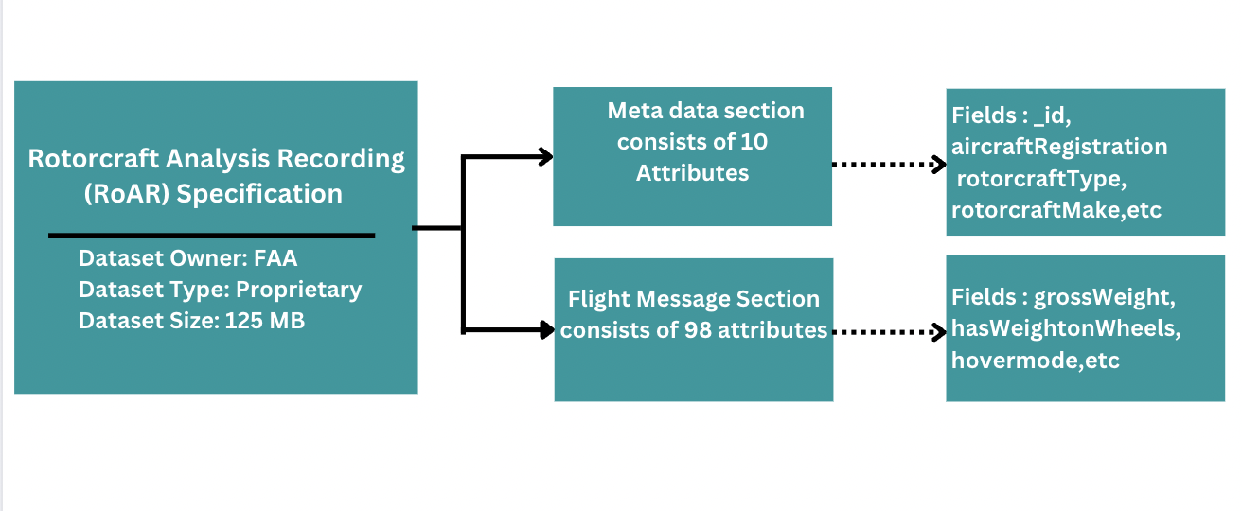

**Figure5: Dataset Overview**

The attributes in the Rotorcraft Analysis Recording (RoAR) Specification are primarily categorized into 2 sections:

1. Meta data section
2. Flight Message Section

As there are several attributes, we further categorized them into different sections as in what field is the attribute is belonging to. The following are the below sections considered.

* Metadata: It includes different properties of the flight such as weather conditions, time, etc., which is used for the data management.
* Flight State Altitudes: It is used to measure an aircraft's altitude at standard air pressure, expressed in hundreds of feet.
* Position: It defines the point where the rotorcraft is heading too i.e., vertical angle or horizontal angle.
* Airframe: An airframe is a basic structure of an airplane or spacecraft excluding its power plant and instrumentation
* Acceleration: A pilot in a steep turn may experience forces of acceleration equivalent to many times the force of gravity. Acceleration is described in units of the force called - Gs.
* Flight controls: Aircraft flight control systems consist of primary and secondary systems. The ailerons, elevator, and rudder constitute the primary control system and are required to control an aircraft safely during flight.
* Engine: It has the power component of an aircraft propulsion system. Most aircraft engines are either piston engines or gas turbines
* Rotors: Rotors is an array to support one or multiple rotors
* Navigation: Includes Global Navigation Satellite System (GNSS).

|  |  |
| --- | --- |
| **Sections** | **Attributes** |
| Metadata | Id, time, latitude, longitude, roll, pitch, yaw, roll rate, pitchrate, yawrate |
| Flight State Altitudes | GPS altitude, Absolutealtitude, barometricaltitudePilot, AltimeterSetting, PilotRadioAltitude, CoPilotRadioAltitude. |
| Flight State Positions | MagneticHeading,TrueHeading, CompassHeading, GroundTrack, sideslip, angleofattack, flightpathangle, verticalFlightPathAngle, HorizontalFlightPathAngle. |
| Flight State Accelerations | rollAcceleration, pitchAccerelation, yawAcceleration, lateralAcceleration, normalAcceleration, longitudionalAcceleration. |
| Flight Controls | cyclicPositionPitch, cyclicPositionRoll, collectivePosition,antiTorquePedalPosition, leftbrakePosition, rightBrakePosition, throttlePosition, hasParkingbrakeEngaged, hasRotorBladeEngaged. |
| Flight State Rates | pitchRate, rollRate, mainRotorInducedInflow , yawRate , turnRate |
| Flight Director | vorApproachArmed, vorApproachCapture , glideslopeArmed, glideslopeCapture, altitudeHold, verticalSpeedHold |
| Airframe | hasLandingGearDown, weightonWheels, grossWeight |
| Engine | totalFuelWeight, e1fuelFlowRate, e2fuelFlowRate, e1FuelPressuregauge, e2fuelPressuregauge, e2OilPressure, e1OilTemperature, e1Torque, e2Torque etc |
| Rotors | mainRotorRpmPercentage, mainRotorRpm, tailRotorRpm,  mainRotorTorque, tailRotorTorque, tailRotorRpmPercentage etc |
| Auto Pilot | selectedAltitude, autopilotRollAttitude, autopilotPitchAttitude, hover mode |
| Times | batteryOperatingTime, elapsedTime, engineOperatingTime, gpsDateTime, timestamp, seconds |
| Air Data Computer | hasAdc1ValidPilot, hasAdc1ValidCopilot, hasAdc2ValidPilot, hasAdc2ValidCopilot |
| Airframe | hasCabinHeaterEnabled, hasCargoHookLoad, hasWeightOnWheels, hasWheelWellFire, hasFloatsDeployed, grossWeight, |
| Aerodynamic Risks | vrsRiskLevel, lteSeverityLevel, lteSeverityLevelCount, lteIdentification |
| Alerts | hasAHRSWarning, hasAvionicFaultCaution, hasBatteryWarning, hasGpwsAlert, hasPilotEvent, hasSasFault, hasStallHornEnabled |

**Table: An Overview of different Sections of the Flight Simulation Attributes**

## Field Descriptions

|  |  |  |  |
| --- | --- | --- | --- |
| **Field Name** | **Description** | **Data Type** | **Source** |
| _id | Primary Key [AIRCRAFT_ID]: [RECORDER_ID]: [START_TIME_IN_MILLISECONDS]: [END_TIME_IN_MILLISECONDS] | String | Original |
| date | Date of Record when it entered system | String | Original |
| time | Time of Record when it entered system | String | Original |
| latitude | The latitude where the rotorcraft is present | Float64 | Original |
| longitude | The longitude where the rotorcraft present | Float64 | Original |
| gpsAltitude | A geometric altitude measured in reference to the WGS84 ellipsoidal model | Float64 | Original |
| magneticHeading | Heading measured from the magnetic poles | Float64 | Original |
| trueHeading | Heading that is relative to the geographic poles | Float64 | Original |
| pitch | Rotation on the y-axis; aircraft pitch attitude | Float64 | Original |
| roll | Rotation on the x-axis; aircraft roll attitude | Float64 | Original |
| yaw | Rotation on the Z-axis; aircraft yaw attitude | Float64 | Original |
| compassHeading | Heading that includes magnetic heading corrected for deviation | Float64 | Original |
| collectivePosition | Full-down/Neutral is zero. Up is by positive percentage. | Float64 | Original |
| e1FuelFlowRate | The fuel flow rate. | Float64 | Original |
| e2FuelFlowRate | The fuel flow rate. | Float64 | Original |
| e1FuelPressureGauge | The fuel pressure. | Float64 | Original |
| e2FuelPressureGauge | The fuel pressure. | Float64 | Original |
| hasRotorBrakeEngaged | If engaged, the rotor brake is on and the rotor RPM equals zero. | String | Original |
| grossWeight | The gross (instantaneous) weight of the rotorcraft in pounds. | Float64 | Original |
| horizontalFlightPathAngle | Angle between the North and the velocity vector | Float64 | Original |
| e1OilPressure | oil pressure of engine 1 | Float64 | Original |
| e2OilPressure | oil pressure of engine 2 | Float64 | Original |
| e1Temperature | engine 1 temperature | Float64 | Original |
| e2Temperature | engine 2 temperature | Float64 | Original |
| e1Torque | torque of engine 1 | Float64 | Original |
| e2Torque | torque of engine 2 | Float64 | Original |
| mainRotorRpm | the main rotor speed in revolutions per min (rpm) | Float64 | Original |
| tailRotorRpm | the tail rotor speed in revolutions per min (rpm) | Float64 | Original |
| mainRotorTorque | The main rotor torque | Float64 | Original |
| hasAutoPilotDisengaged | Auto pilot engaged or disengaged switch | Boolean | Original |
| outsideAirTemperature | The outside air temperature near the rotocraft | Float64 | Original |
| hasBatteryWarning | Indicates that there is a battery warning, ex: low battery or battery failure warning | Boolean | Original |
| hasEngineChipCaution | caution indicator for engine chip light | Boolean | Original |
| hasFuelLowCaution | caution indicator for low fuel condition | Boolean | Original |
| hasMainRotorLowRpmWarning | Indicates the main rotor RPM goes much below the bottom of the green arc. | Boolean | Original |
| hasMainRotorHighRpmWarning | Indicates the main rotor RPM goes much above the red line | Boolean | Original |
| hasTransmissionChipCaution | caution indicator for transmission chip light | Boolean | Original |
| hasTransmissionOilTemperatureWarning | indicates that the engine is running excessively hot | Boolean | Original |
| hasTransmissionOilPressureWarning | Indicates the engine oil pressure is low | Boolean | Original |
| vil | The vertically integrated liquid level: -97 No WX Data, -2 Not Processed, -1 Clear Skies, 0 Very light precipitation, 1 Light precipitation, 2 Light to moderate rain, 3 Moderate to heavy rain, 4 Heavy rain, 5 Very heavy rain; hail possible, 6 Very heavy rain and hail; large hail possible | Discrete | Original |

**Table: FAA Dataset Fields, descriptions, and datatypes**

* **_id (Type: String)-** It is ID of the Aircraft, and it is in the format [AIRCRAFT_ID]: [RECORDER_ID]: [START_TIME_IN_MILLISECONDS]: [END_TIME_IN_MILLISECONDS].
* **Date (Type: String)** - Date of Record when it entered system. The date is displayed in ISO 8601 format (YYYY-MM-DD).
* **Time (Type: String)-** Time of Record when it entered system. The time is displayed in ISO 8601 format (Thh:mm:ss+offset).
* **latitude (Type: Float64)** - This is the latitude where the aircraft is present.
* **Longitude (Type: Float64)-** This is the longitude where the aircraft is present.
* **gpsAltitude** (Type: Float64)-A geometric altitude measured in reference to the WGS84 ellipsoidal model. GPS altitude is a close approximation to true altitude
* **magneticHeading** (Type: Float64)- Heading measured from the magnetic poles. This heading is directly related to the magnetic poles as with AHRS. However, magnetic heading devices can be inaccurate based on interference from the rotorcraft, in which case, deviation correction would need to be applied to become accurate again. When deviation correction is applied magnetics heading is then considered to be compass heading. Magnetic heading equals true heading +- variation.
* **trueHeading (Type: Float64)-** Heading that is relative to the geographic poles. True Heading equals true course +- wind correction angle.
* **Pitch (Type: Float64)-** It represents the Rotation of rotorcraft on the y-axis, and it represents the aircraft pitch attitude.
* **Roll (Type: Float64)-** It represents the Rotation of rotorcraft on the X-axis, and It represents the aircraft roll attitude.
* **Yaw (Type: Float64)-** It represents the Rotation of rotorcraft on the Z-axis, and It represents the aircraft yaw attitude.
* **compassHeading (Type: Float64)**- Heading that includes magnetic heading corrected for deviation. A magnetic direction indicator or gyroscopic direction indicator would reflect the compass heading value.
* **collectivePosition** (**Type: Float64)-**It represents the Full-down/Neutral is zero. Up is by positive percentage.
* **e1FuelFlowRate** **(Type: Float64)**- It represents the aircraft fuel flow rate.
* e2FuelFlowRate **(Type: Float64**)- It represents the aircraft fuel flow rate.
* e1FuelPressureGauge **(Type: Float64)-** It represents the aircraft fuel flow pressure.
* e2FuelPressureGauge **(Type: Float64)-** It represents the aircraft fuel flow pressure.
* **hasRotorBrakeEngaged (Type: String)-** If engaged, the rotor brake is on and the rotor RPM equals zero, i.e., the rotor cannot turn.
* **grossWeight (Type: Float64)-** It represents the gross weight of the rotorcraft in pounds.
* **horizontalFlightPathAngle (Type: Float64)**- It represents the angle between the North and the velocity vector relative to wind (in the body xy-plane)

## Rotorcraft Manoeuvres

|  |  |
| --- | --- |
| Maneuvers | Operation |
| 1. Normal Climb | It is the operation of increasing the altitude of an aircraft. [8] |
| 1. Turns | A turn is an operation used to change the heading of a helicopter. [8] |
| 1. Normal Descent | A normal descent is a maneuver in which the helicopter loses altitude at a controlled rate in a controlled attitude. [8] |
| 1. Hover | Hover is a maneuver in which the helicopter is maintained in nearly motionless flight over a reference point at a constant altitude and on a constant heading. [8] |
| 1. Taxiing | Taxiing is a maneuver used to operations on or near the surface of taxiways or other prescribed routes. There are 3 different types. They are hover taxi, air taxi, surface taxi. [8] |
| 1. Straight-and-Level Flight | It is a flight in which constant altitude and heading is maintained. [8] |
| 1. Quick Stop | This maneuver is used to decelerate from forward flight to a hover. It is often used to abort takeoffs, to stop if something blocks the helicopter flightpath, or simply to terminate an air taxi maneuver. A quick stop is usually practiced on a runway, taxiway, or over a large grassy area away from other traffic or obstacles. [9] |
| 1. Steep Approach | A steep approach is used primarily when there are obstacles in the approach path that are too high to allow a normal approach. A steep approach permits entry into most confined areas and is sometimes used to avoid areas of turbulence around a pinnacle. [9] |
| 1. Confined area operations | A confined area is an area where the flight of the helicopter is limited in some direction by terrain or the presence of obstructions, natural or manmade. [9] |
| 1. Slope Operations | During slope operations, make allowances for wind, barriers, and forced landing sites in case of engine failure. Since the slope may constitute an obstruction to wind passage, anticipate turbulence and downdrafts. [9] |

**Table: Showing the different types of flight maneuvers and its operations**

## Data Conditioning

### Challenges

The team was provided with four datasets where in every dataset, all the attributes (column names) were the same. Before combining, analyzing all the four datasets to find any errors was the challenging job. Later after analyzing, we combined all four datasets to one single dataset so that with huge number of records we can get good insights from the data.

### Additional Data Cleaning Methods

The dataset which the team got was already clean without any missing values, duplicate values, discrepancies, and noisy data. All the data was neat and clean. The data is of many types like float, string, and Boolean values. We converted Boolean values to binary with 0 meaning FALSE and 1 being TRUE. Reading these values into the tool is easy to understand and analyze.

### Data Extraction Techniques

After the underlying cleaning efforts inside the Flight Simulation dataset, the Group pushed ahead with considering the "Altitude" field as is made up of three components, yaw, pitch, and roll. For Instance, changes to the altitude are defined as zero pitch, zero roll and heading direction parallel with the runway.

* Irregularities in reporting: multiple formatting of the data across all the variables we need to extract (e.g., date and time are present as separate variables in the dataset, as another variable timestamp is present which represent the same date and time. So, we can use either one or drop another variable)

To limit the amount of data but still have great coverage over essential characteristics, sampling methods can be applied. These methods are divided into two categories, data-level and algorithmic level. Algorithmic level utilizes Machine learning (ML) to accumulate imbalanced data. Data-level focus on manipulating the data through oversampling and under sampling. The oversampling approach focuses on duplicating samples of less common scenarios in the dataset.

These scenarios are then more likely to be interpreted by the neural network. However, this could result in overfitting where the dataset is too specific, limiting the neural network’s performance. Different approaches which utilize oversampling have been researched to improve its balancing features further. The dataset can be divided into different clusters which represent each class of interest in the environment. By oversampling each cluster separately, the dataset will, with more detail, describe the features of the classes. Oversampling can also be combined with boosting algorithms to find and fix flaws in the dataset. Boosting algorithms can find hard examples from the dataset and utilize oversampling to generate synthetic data to balance it. The under-sampling approach focuses on removing common samples to balance the dataset. This method can be problematic since it can remove useful dataset samples, which limit detection of specific cases. To mitigate the loss of useful data, one-sided selection can identify redundant data that is too similar and remove it.

To address this, the Group utilized a blend of data cleaning and extraction procedures and tools, including Microsoft Power BI (designing, cleaning, separating, and combining), Python, R libraries and tools, and followed an essential repetitive interaction to clean-extract-merge-inspect.

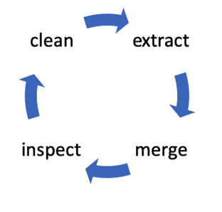

**Figure: The Cycle process of Data Cleaning**

The last step was to blend the cleaned datasets into the one dataset which the Group used to lead the examinations. The final datasets were combined based on the Flight Simulation dataset Primary key ("_id"). The excess datasets were conveged with the FAA dataset after data arrangement was finished involving one-of-a-kind elements in each dataset like date and time.

### Microsoft Power BI

To address the challenges in the dataset, and tool that demonstrated particularly helpful was Microsoft Power BI. Power BI is a genuinely new "visual information readiness instrument that empowers us to clean and standardize data without composing any code, to lessen the time it takes to plan data for analysis.

Power BI lets you connect to and import all sorts of datasets and bring all of it together in one place. Datasets can also source data from dataflows. A Power BI report is one or more pages of visualizations such as line charts, maps, and tree maps. Visualizations are also called visuals. All the visualizations in a report come from a single dataset. You can create reports from scratch within Power BI, import them with dashboards that colleagues share with you, or Power BI can create them when you connect to datasets from Excel, Power BI Desktop, databases, and SaaS applications. For example, when you connect to a SaaS application, Power BI imports a pre-built report.

A dashboard is something you create in the Power BI service. It is a single canvas that contains zero or more tiles and widgets. Each tile pinned from a report or from Q&A displays a single visualization that was created from a dataset and pinned to the dashboard. Entire report pages can also be pinned to a dashboard as a single tile.

We have imported four datasets provided by the FAA and loaded the datasets in Power BI. After loading the datasets, we created a relationship between the tables (one-to-one relationship) using the modeling tab in Power BI. Secondly, we took attributes like latitude and longitude to understand that which locations were selected for the rotorcraft simulation.

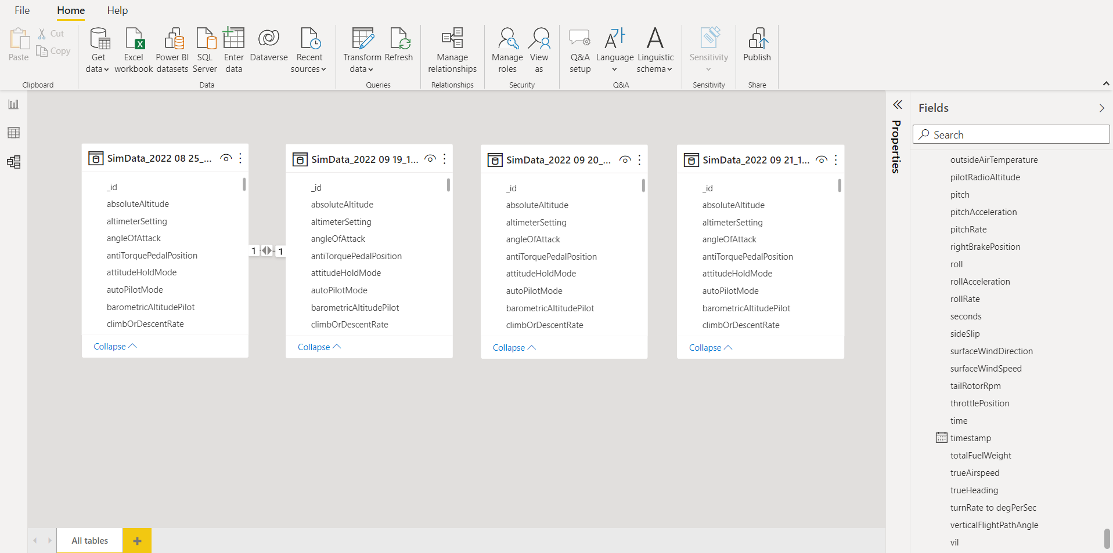

**Figure:** Imported Datasets to Power BI

## Data Quality Assessment

### Completeness

There were different fields in the dataset that were either represents same information as single or in combination they are representing same information, or the qualities entered were something very similar across all rows. These fields were determined to not be of value for the analysis and were removed. These included:

The below date and time represent the event of the rotorcraft and timestamp also represent same event. So, we can drop any one of the variables.

-date: 8/25/2022

-time: 53:13.3

-timestamp: 2022-08-25T18:53:13.253Z

-hasMainRotorLowRpmWarning: All values were ‘FALSE’

-hasMainRotorHighRpmWarning: All values were ‘FALSE’

- nav1VerticalDeviation: All values were ‘0’

- nav2HorizontalDeviation: All values were ‘0’

- nav2VerticalDeviation: All values were ‘0’

- gpsVerticalDeviation: All values were ‘0’

### Missing Data

-In this dataset there are no missing values.

### Uniqueness

A few fields contained comparable data, explicitly related to date and time. There are date and time in the dataset under two distinct variables, but they represent same information. Below are some examples that represents same information or same values.

- date

- time

- commRadio1

- commRadio2

- navRadio1

- navRadio2

### Accuracy

The dataset which the team got was already clean without any missing values, duplicate values, discrepancies, and noisy data. All the data was neat and clean. Converting the Boolean values to binary and reading these values into the tool makes it easy to analyze and understand.

### Atomicity

The dataset contains many rows and columns that is many records which is helpful to build a model without any issues.

### Conformity

Though most of the data confirms to standards, few attributes like “date”, “time” and “timestamp” represent same event values.

## Other Data Sources

The Team had initially considered using the Autonomous Helicopter Aerobatics open-source dataset from Stanford University and Rotorcraft Landing Sites – An AI-Based Identification System open-source dataset from Harvard Dataverse. However, this was no longer necessary as 4 different proprietary datasets based on different demographics with a total size of 350MB were provided by the FAA partner.

# Analytics, Algorithms, and Visualizations

The data provided by FAA is from the RoAR repository which is like that of any GitHub repository having different attributes and measures. We were given the data from the simulator which the FAA personnel used to operate. After gathering the data, we tried to figure out the data and tried to understand that what meaningful insights and analysis that FAA was trying to retrieve from the data.

When parsing out the data the Team gained a better understanding of what the data included which led the Team to ask the following additional questions:

* What are the locations where the rotorcraft manoeuvring has taken place? (Using lat and long)
* Is there any weight difference in the rotorcraft when it has weight on wheels or does the fuel weight makes any difference in the rotorcraft?
* Is there any relation between the engine’s fuel flow rate and fuel pressure gauge?

The Team conducted research on which analyses best fit the questions we were attempting to answer. This involved researching the inputs required for each possible analysis and the model output. The Team then discussed which analyses would best answer the questions identified in the problem statement.

## Location Analysis

Using Power BI, the team has considered to use columns latitude and longitude to create a geographical visualization. The team has taken 4 different datasets and created the visualizations.

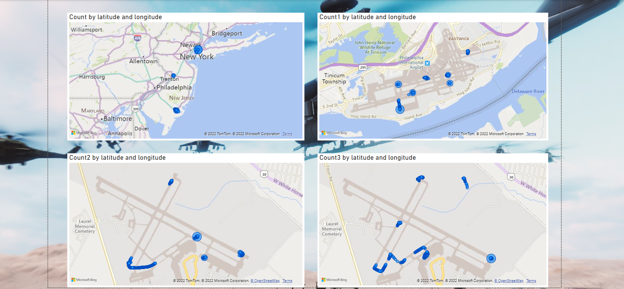

**Figure:** Geographical Visualization in Power BI

From the analysis, it has been observed that the rotorcraft simulations were performed in multiple locations. From the first quarter, the simulations were performed in areas like New Jersey, New York, and Trenton, from the second quarter, it has been depicted that the location was Philadelphia International airport and the simulations in last quarter display that simulations were from Atlantic City airport.

## Autopilot Mode analysis

An autopilot is a device used to guide an aircraft without direct assistance from the pilot. Early autopilots were only able to maintain a constant heading and altitude, but modern autopilots can control every part of the flight envelope from just after take-off to landing. Modern autopilots are normally integrated with the flight management system (FMS) and, when fitted, the auto throttle system.

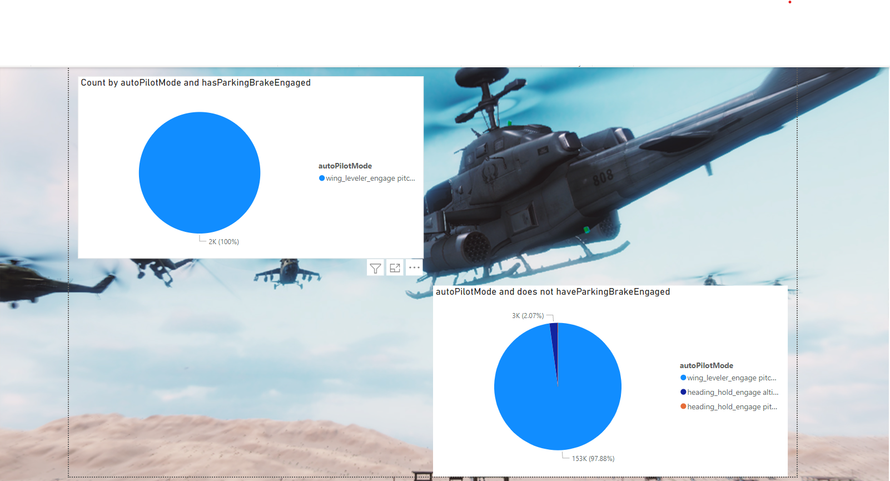

From the visualizations, it can be observed that the wing_leveler_engage pitch_sync_engage is the most used autopilot mode among the three modes. In the first plot, the wing_leveler_engage pitch_sync_engage mode constitutes to 100% when the parking brake is engaged; in the second graph defines the autopilot mode when the parking brakes are not engaged and 97% of the times it is the wing_leveler_engage pitch_sync_engage mode followed by the heading_hold_engage altitude_hold_engage mode with 2%.

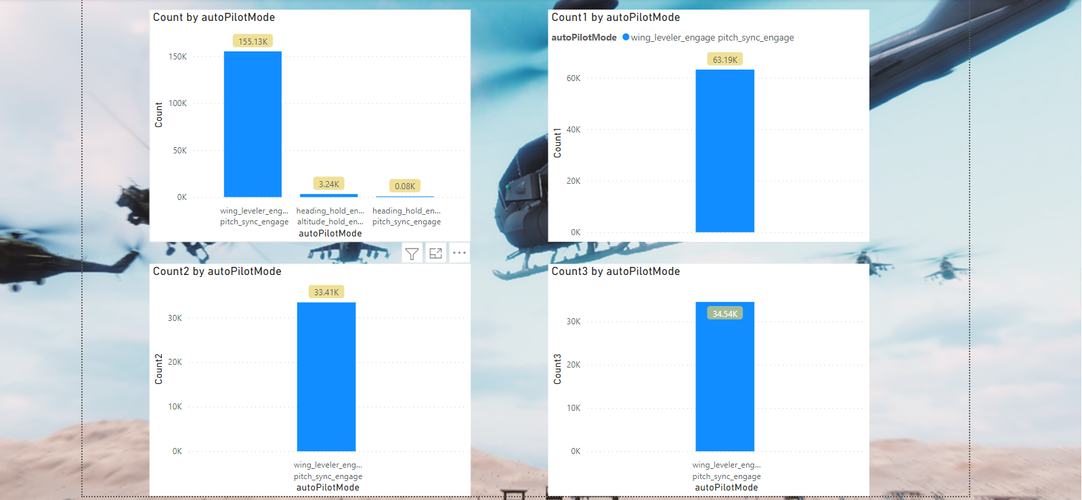

We have gathered the same 4 datasets (25th August 22, 19th 20th 21st September 22) and have analyzed and created a bar plot which defines which mode constituted the more in datasets and it can be observed that in all the graphs the wing_leveler_engage pitch_sync_engage mode is the most compared to the other two.

## Naïve Bayes Classifier

Naïve Bayes algorithm is a supervised learning algorithm, which is based on Bayes theorem and used for solving classification problems. It is mainly used in text classification that includes a high-dimensional training dataset. Naïve Bayes Classifier is one of the simple and most effective Classification algorithms which helps in building the fast machine learning models that can make quick predictions with high functionality. It is a probabilistic classifier, which means it predicts based on the probability of an object. Some popular examples of Naïve Bayes Algorithm are spam filtration, Sentimental analysis, and classifying articles.

The Naïve Bayes algorithm is composed of two words “Naïve” and “Bayes”. It is called Naïve because it assumes that the occurrence of a certain feature is independent of the occurrence of other features. It is called bayes as it depends on bayes theorem.

### Bayes Theorem

* Bayes' theorem is also known as **Bayes' Rule** or **Bayes' law**, which is used to determine the probability of a hypothesis with prior knowledge. It depends on the conditional probability.
* The formula for Bayes' theorem is given as:

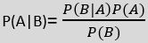

Where,

**P(A|B) is Posterior probability**: Probability of hypothesis A on the observed event B.

**P(B|A) is Likelihood probability**: Probability of the evidence given that the probability of a hypothesis is true.

**P(A) is Prior Probability**: Probability of hypothesis before observing the evidence.

**P(B) is Marginal Probability**: Probability of Evidence.

Pros

* Naïve Bayes is one of the fast and easy ML algorithms to predict a class of datasets.
* It can be used for Binary as well as Multi-class Classifications.
* It performs well in multi-class predictions as compared to the other Algorithms.

Cons

* Naive Bayes assumes that all features are independent or unrelated, so it cannot learn the relationship between features.

There are 3 types of Naïve Bayes models. They are

1. Gaussian Naïve Bayes
2. Multinomial Naïve Bayes
3. Bernoulli Naïve Bayes

We choose to use the Gaussian Naïve Bayes technique for this project, because the data that has been presented to us is continuous.

### Gaussian Naïve Bayes Classifier:

In Gaussian Naïve Bayes, continuous values associated with each feature are assumed to be distributed according to gaussian distribution. A gaussian distribution is also called Normal Distributed. An approach to create a simple model is to assume that the data is described by a Gaussian distribution with no co-variance (independent dimensions) between dimensions. This model can be fit by simply finding the mean and standard deviation of the points within each label, which is all what is needed to define such a distribution. When plotted, it gives a bell-shaped curve which is symmetric about the mean of the feature values.

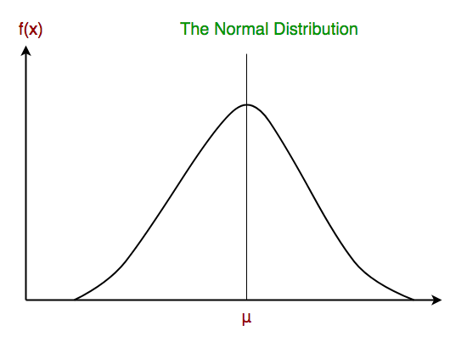

The conditional probability is given by:

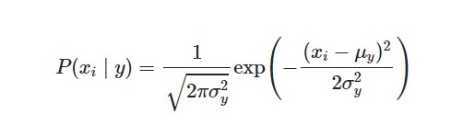

The dataset is divided into two parts, namely, predictor variables and target variables.

* The independent variables of the dataset are pitch, roll, yaw.
* The dependent variables of the dataset are rollAcceleration, pitchAcceleration, yawAcceleration, lateralAcceleration, normalAcceleration, mainRotorRpmPercentage, mainRotorRpm, tailRotorRpm, mainRotorTorque.
* We decided to use Gaussian Naïve Bayes Classifier as one of our models.

To proceed with Gaussian Naïve Bayes Classifier, we first found out categorical and numerical variables from our dataset. Where we found out ‘autoPilotMode’ is the only categorical variable and there are 50 Numerical variables in the finalized dataset. The numerical and categorical variables are shown below in the picture.

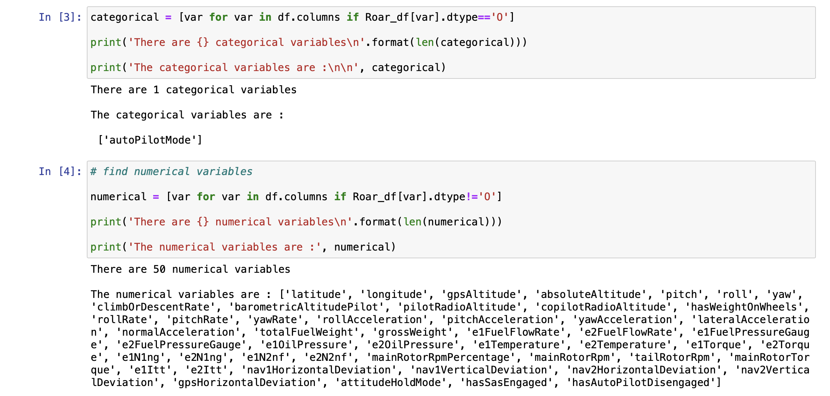

We plotted a scatterplot using seaborn library in python between e1FuelFlowRate which is the fuel flow rate in engine 1 and e1OilPressure which is the oil pressure of engine 1.

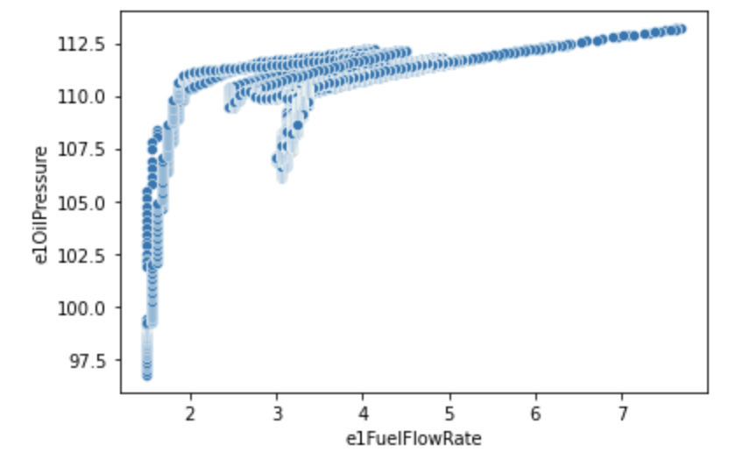

Then for the model training and testing, we split our dataset into training and testing datasets with the ratio of 70:30 respectively.

We used Standard Scalar to scale the data to unit variance because the characteristics of the input dataset differ greatly between their ranges, or simply they are measured in different units of measure. By doing this the model performs better and gives us the better results. The train, test, and scaling of the dataset are shown below in the picture.

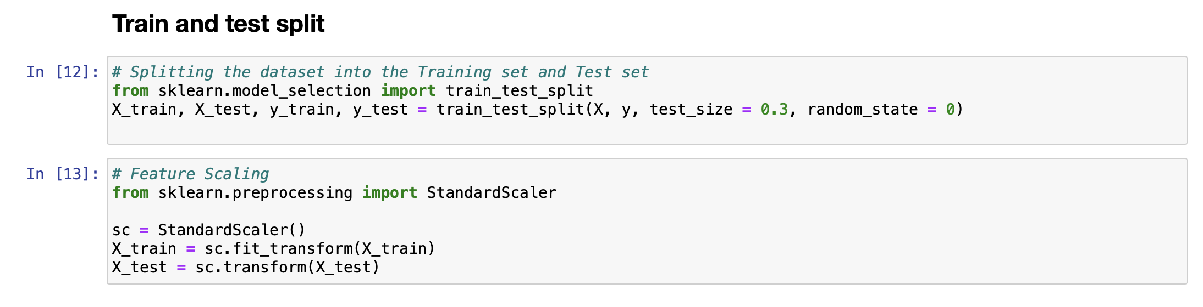

### Gaussian Naïve Bayes Classifier

In Gaussian Naive Bayes, it is assumed that each feature's continuous values are distributed according to a Gaussian distribution (Normal distribution). It produces a bell-shaped curve that is symmetrical around the mean of the feature values when plotted.

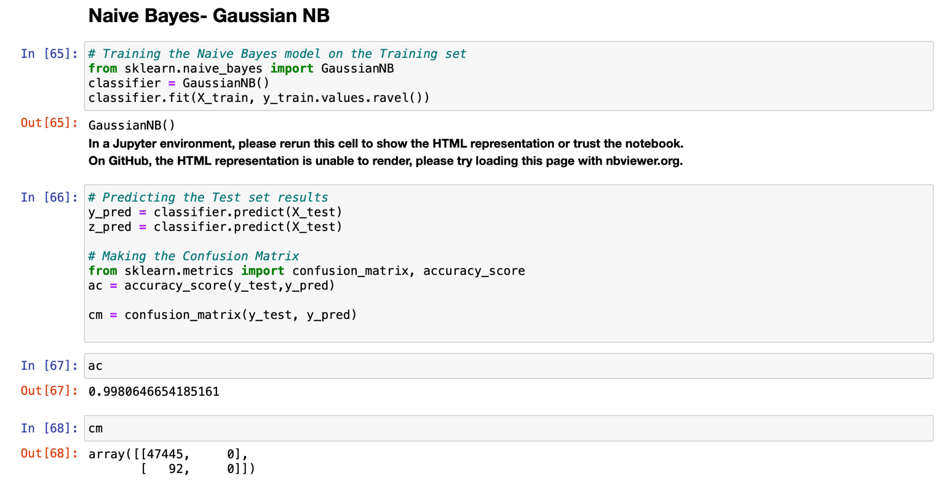

After importing the Gaussian Naïve Bayes Classifier and fitting the model with training values, we predicted with test set values, and the accuracy of the model came out to be 99.8%. The confusion matrix with array is displayed above.

To display the confusion matrix with heatmap, we used seaborn and plotted the heatmap which is shown below.

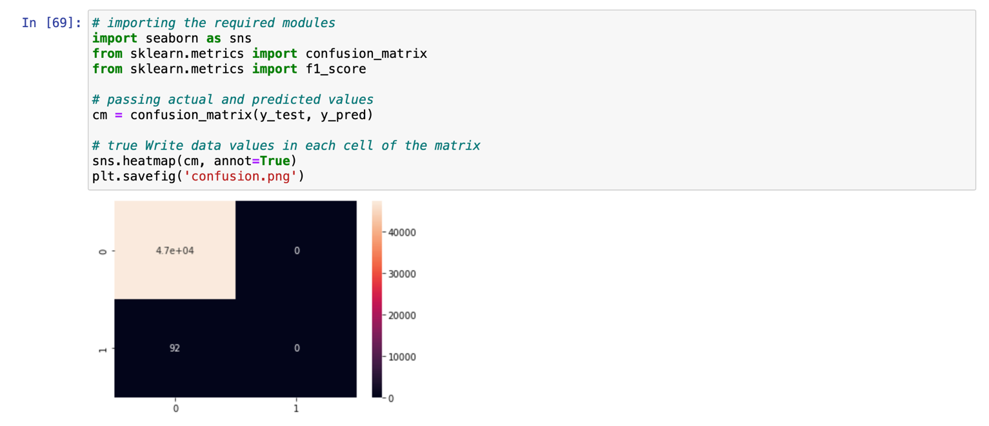

## Random Forest

Random forests or random decision forests are an ensemble learning method for classification, regression and other tasks that operates by constructing a multitude of decision trees at training time. For classification tasks, the output of the random forest is the class selected by most trees. For regression tasks, the mean or average prediction of the individual trees is returned.

### Working

A random forest is a collection of Decision Trees, Each Tree independently makes a prediction, the values are then averaged (Regression) / Max voted (Classification) to arrive at the final value.

The strength of this model lies in creating different trees with different sub-features from the features. The Features selected for each tree is Random, so the trees do not get deep and are focused only on the set of features. Finally, when they are put together, we create an ensemble of Decision Trees that provides a well-learned prediction.

Random Forest provides much better accuracy and efficiency than a decision tree, this comes at a cost of storage and computational power.

Hyper parameters help us to have a certain degree of control over the model to ensure better efficiency, some of the commonly tuned hyperparameters are below.

**N_estimators =** This parameter helps us to determine the number of Trees in the Forest, higher the number, we create a more robust aggregate model, but that would cost more computational power.

**max_depth =** This parameter restricts the number of levels of each tree. Creating more levels increases the possibility of considering more features in each tree. A deep tree would create an overfit model, but in Random Forest this would be overcome as we would ensemble at the end.

**max_features** -This parameter helps us restrict the maximum number of features to be considered at every tree. This is one of the vital parameters in deciding the efficiency. Generally, a Grid search with CV would be performed with various values for this parameter to arrive at the ideal value.

### Classifier vs Regressor

A random forest classifier works with data having discrete labels or better known as class.

Example- A patient is suffering from cancer or not, a person is eligible for a loan or not, etc.

A random forest regressor works with data having a numeric or continuous output and they cannot be defined by classes.

**Training of Random Forests**:

The "**bagging**" method is typically used to train the decision trees in an ensemble, including the trees in a Random Forest. The "bagging" approach utilizes a Bootstrap Aggregation ensemble machine learning technique. An ensemble technique combines predictions from various machine learning algorithms to provide predictions that are more precise than those from a single model. Another ensemble technique is Random Forest.

To create sample datasets for each model, **Bootstrap** randomly selects rows and features from the dataset. These sample datasets are combined and reduced to summary statistics based on the observation through the process of aggregation. High variance algorithms like decision trees can have their variance reduced via Bootstrap Aggregation.

**Variance** is a mistake brought on by sensitivity to minute variations in the training dataset. When there is a lot of variance, an algorithm will simulate the dataset's noise—irrelevant data—instead of the signal—the anticipated results. We refer to this issue as overfitting. In training, an overfitted model will perform well, but in a real test, it won't be able to tell the difference between noise and signal.

Applying the bootstrap method to a high variance machine learning system is known as **bagging**.

### Random Forest Regressor

In this model we are predicting the value ‘hasAutoPilotDisengaged’. To build a model, we split our dataset into training and testing in the ratio of 70:30 respectively.

We built a Random Forest Regressor model with 1000 trees and predicted values based on test set values. The values which we got are:

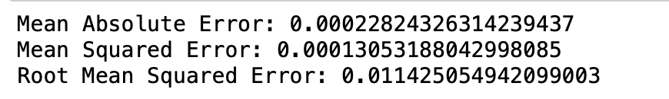

### Random Forest Classifier

In this model we considered, ‘pitch’, ‘roll’, and ‘yaw’ as features and 'hasAutoPilotDisengaged', 'attitudeHoldMode', 'hasSasEngaged' as output variables or labels. To build a model, we split our dataset into training and testing in the ratio of 70:30 respectively.

We built a Random Forest Classifier model with 1000 trees and predicted values based on test set values. The accuracy of the model came out to be 99.9%.

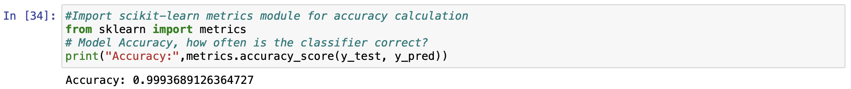

To plot a heatmap, we used seaborn and passed the confusion matrix values to the heatmap. The figure is shown below:

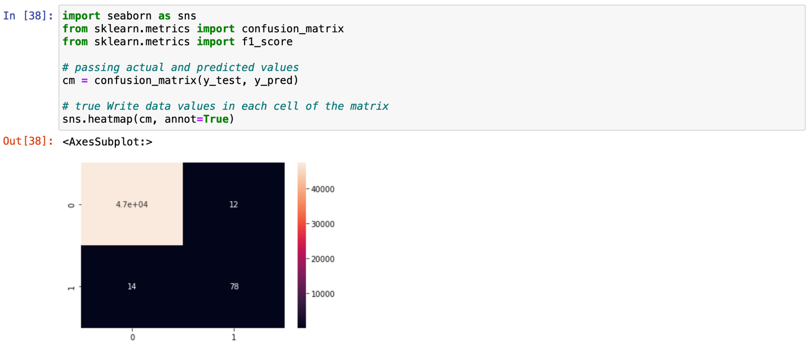

Decision Tree of a Random Forest

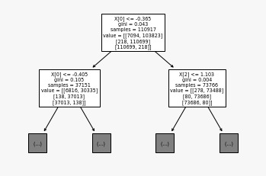

## Logistic Regression

Based on some dependent variables, the machine learning classification process known as logistic regression is used to forecast the likelihood of a given class. In essence, the logistic regression model generates the logistic of the outcome after computing the sum of the input features (in most cases, there is a bias term).

For a binary classification problem, logistic regression's result is always between 0 and 1, which is appropriate. The likelihood that the current sample will be assigned to class=1 increases with increasing value, and vice versa.

The formula is given by:

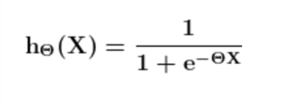

**Working**

Predicting a numeric result or a qualitative class is often how machine learning works. The former is frequently known as a regression issue. In a linear regression situation, the prediction is a numerical value, and the input is a continuous variable. The task is viewed as a classification challenge when anticipating a qualitative outcome (class).

Though not all algorithms neatly fit into this straightforward divide, logistic regression is a notable example. Due to its use of quantifiable correlations between variables to predict outcomes, logistic regression is a member of the regression family. It accepts both continuous and discrete variables as input, in contrast to linear regression, and its output is qualitative. Additionally, it forecasts a discrete class like "Yes/No" or "Customer/Non-customer."

The logistic regression algorithm is used in practice to examine correlations between variables. Using the Sigmoid function, which transforms numerical data into an expression of probability between 0 and 1.0, it assigns probabilities to discrete outcomes. Depending on whether the event occurs, probability ranges from 0 to 1. With a cut-off of 0.5, you can divide the population into two groups for binary predictions. Everything in group A is thought to be greater than 0.5, and everything in group B is seen to be less than 0.5.

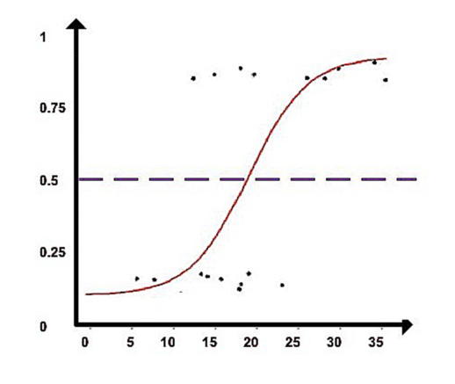

After data points are classified using the Sigmoid function, a hyperplane is employed as a decision line to divide two categories (as much as possible). The decision boundary can then be used to forecast the kind of upcoming data points.

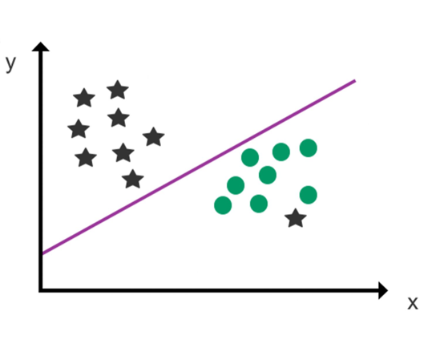

**Building a Model**

Here, roll, pitch, and yaw are used as input variables or features and hasAutoPilotDisengaged as the output variable or label. The dataset is split into 70% of training and 30% of testing data. And the dataset is scaled using a Standard Scalar.

The heatmap is built using matplotlib library in python. It is shown below.

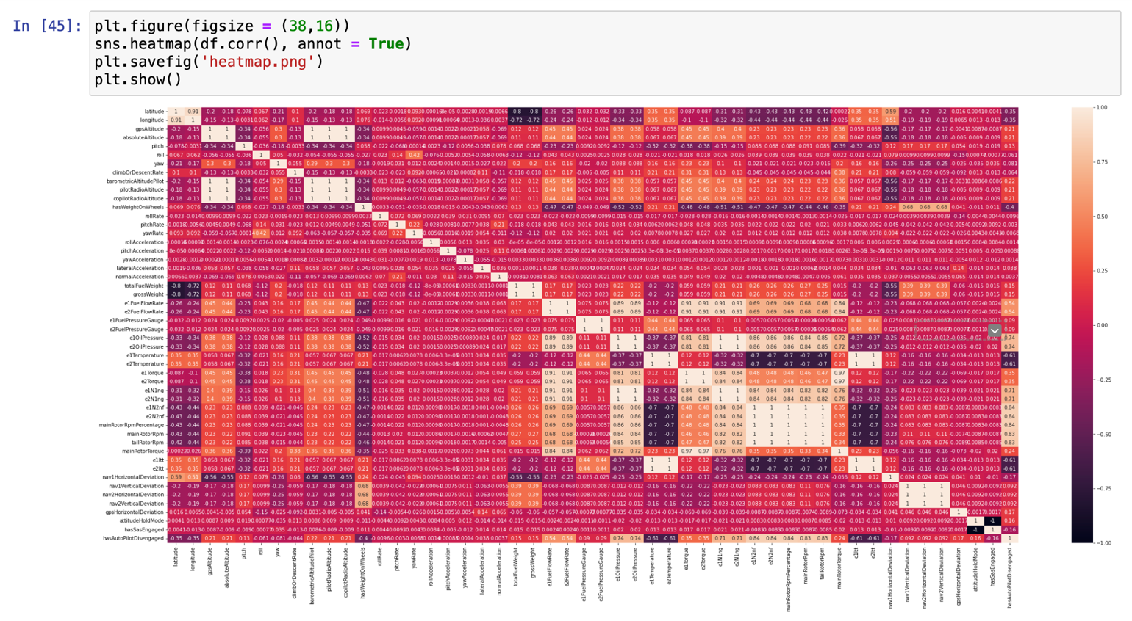

After the model is fitted with the trained set values, the accuracy is found using the test set results and predicted values. The accuracy of the test set came out to be 93.6%.

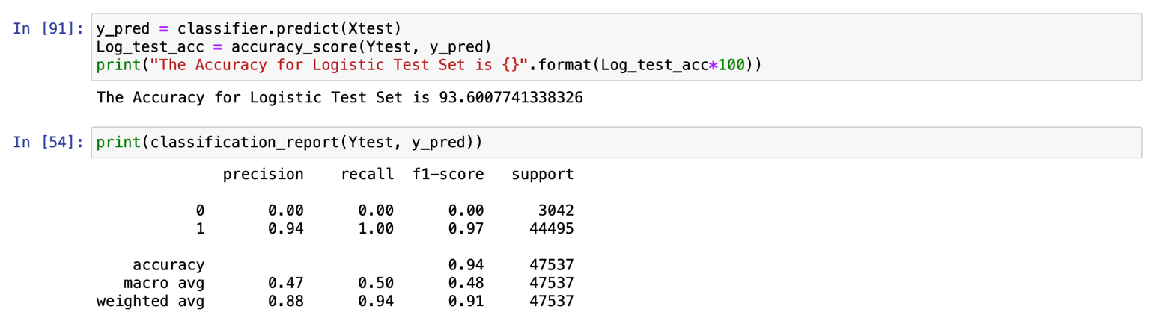

The confusion matrix is built using matplotlib in python.

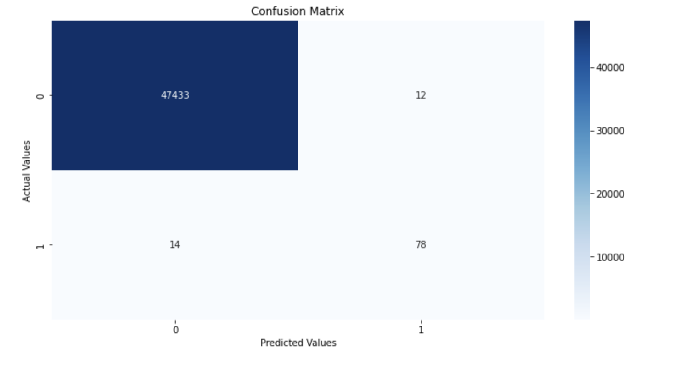

## Decision Tree

The most effective and well-liked technique for categorization and prediction is the decision tree. A decision tree is a type of tree structure that resembles a flowchart, where each internal node represents a test on an attribute, each branch a test result, and each leaf node (terminal node) a class label.

**Construction**

By dividing the source set into subgroups based on an attribute value test, a tree can be "trained". It is known as recursive partitioning to repeat this operation on each derived subset. When the split no longer improves the predictions or when the subset at a node has the same value for the target variable, the recursion is finished. Decision tree classifier building is ideal for exploratory knowledge discovery because it doesn't require parameter configuration or domain understanding. High-dimensional data can be handled via decision trees. Decision tree classifiers are often accurate. A popular inductive method for learning classification information is decision tree induction.

The **Gini Index** is a number that measures how accurately a divide is between the groups that are categorized. A score between 0 and 1, where 1 represents a randomly distributed distribution of the elements within classes, is evaluated using the Gini index. The assessment statistic we'll use to assess our decision tree model is the Gini Index.

**Building a Model**

In this model we considered pitch, roll, and yaw to be the input variables and 'hasAutoPilotDisengaged', 'attitudeHoldMode', 'hasSasEngaged' to be the output variables. We split the dataset into 70% training and 30% testing datasets, and then we scaled the data using Standard Scalar.

After building the model, we evaluated the model by test set results and predicted values by calculating the accuracy of the model. It came out to be 99.8%.

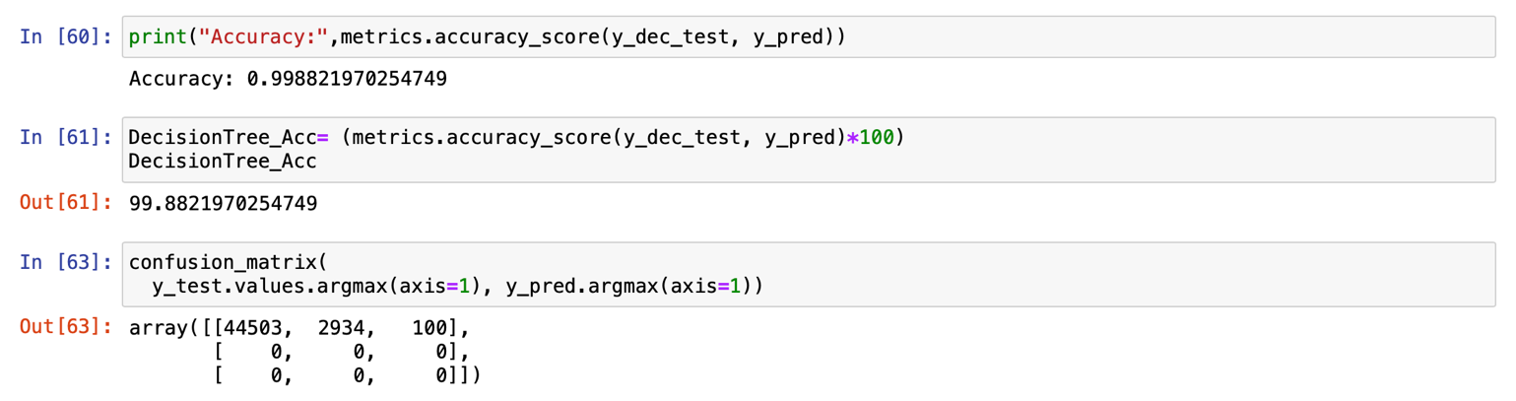

## Conclusion

After building and evaluating all the models, the accuracy of the Random Forest model came out to be the highest among all others.

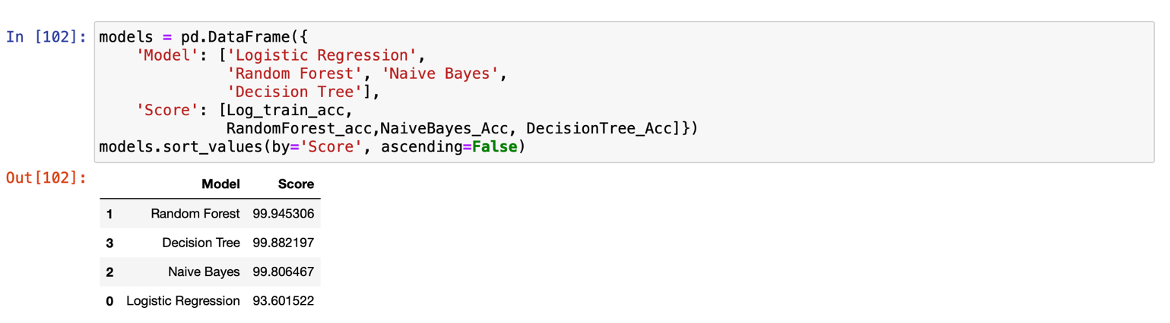

# Findings and Summary

This was a both a challenging and extremely rewarding project for our Team. The FAA partner provided a rich dataset with numerous possibilities, unlimited potential, and afforded the team the freedom to explore and make recommendations on where to go, based on what the data was telling us. The fact that there had not been any previous studies with the dataset was exciting and at times, a little intimidating.

The main challenge was dealing with such huge datasets and running ML models along with creating visualizations using Power BI. We had to remove columns to reduce the size of the dataset and remove any noisy and unnecessary values for the models to perform better and get good accuracy score.

The analyses we performed provided unique insights to the FAA partner, we believe we were able to show them some new, and useful information in their data and confirm some of their own hypotheses.

The team implemented four different ML algorithms (Random Forests, Logistic Regression, Naïve Bayes classifiers, Decision tree and all the models produced good accuracy levels (>90%).

We performed in depth analysis on the roll, pitch, and yaw attributes to understand the altitudeHoldMode and has SAS enegaged mode.

In conclusion, the Team was able to provide valuable insight to our FAA partner and we hope that the work we have completed will continue to evolve in future DAEN 690 courses.

## Recommendations

The Team collected several recommendations for the FAA partner throughout the course of this project. When we first received the datasets, it was apparent that there was huge amount of information that had the **“wing_leveler_engage_pitch_sync_engage”** mode as the highest for almost all the rows. To facilitate easier analysis in future, we recommend to the partner to use different autopilot modes to get great number of visuals.

Lastly, the Team has provided information to the FAA partner for hosting a possible Kaggle[1] or Challenge.gov[2] competition for future analyses.

# Appendices

## Appendix – Code and Datasets

All code and datasets used for this project can be viewed at the Team’s GitHub page (link below).

<https://github.com/namanlahoti/Working-on-Identification-Characterization-and-Analysis-of-Rotorcraft-Flight-Maneuvres-using-Simul>

## Appendix – Agile Development

The project was conducted as an Agile Development, with 5 Sprints conducted in total and each Sprint lasting 2-3 weeks. Roles were defined at the beginning of the project and activities captured using an Agile JetBrains YouTrack Agile Dashboard. While specific Agile roles were assigned, the team worked cohesively to address work that best fit skillsets and fill any gaps to keep the project on track.

## Project Roles

* SCRUM Master – Uma Kotrica
* Product Owner – Naman Lahoti
* Developers
  + Lokesh Reddy Mekala
  + Chandana Marreddy
  + Sahith Reddy Battapuram

## Appendix – Bibliography

[1] Saetti, U. (2019), *Rotorcraft Simulations with Coupled Flight Dynamics, Free Wake, and*

*Acoustic,* <https://ascent.aero/documents/2017/06/rotorcraft-simulations-with-coupled-flight-dynamics-free-wake-and-acoustics.pdf/>

[2] Leybold, H (1971), *Simulation of Flight Maneuver-Load Distributions By Utilizing Stationary, Non-Gaussian Random Load Histories,* <https://ntrs.nasa.gov/api/citations/19720005259/downloads/19720005259.pdf>

[3] Stepner, D (1973), *Maximum Likelihood Identification and Optimal Input Design For Identifying Aircraft Stability And Control Derivatives* <https://ntrs.nasa.gov/api/citations/19730012344/downloads/19730012344.pdf>

[4] Helicopter Aviation. <http://www.copters.com/pilot/maneuvers.html>.

[5] FAA 14 Part 60 (2016), “Flight Simulation Training Device Initial and Continuing

Qualification and Use,” FAA 14 Part 60 Appendix C to Part 60-Qualification Performance Standards for Helicopter Full Flight Simulators. Accessed 13 September 2022.

[6] EASA CS-FSTD(H) (2012), “Certification Specifications for Helicopter Flight Simulation Training Devices,” European Aviation Safety Agency EASA CS-FSTD(H), June, [https://www.easa.europa.eu/ certification-specifications/cs-fstdh-helicopter-flight-simulation-training-devices](https://www.easa.europa.eu/%20certification-specifications/cs-fstdh-helicopter-flight-simulation-training-devices) Accessed 13 September 2022.

[7] Peters, D.A., and He, C. (1991), “Correlation of Measured Induced Velocities with a Finite State Wake Model,” Journal of American Helicopter Society, Vol. 37, No. 3, Jul. Accessed 13 September 2022.

[8] n.d. *Helicopter Flying Handbook*. [ebook] FAA. Available at: <1. https://www.faa.gov/regulations_policies/handbooks_manuals/aviation/helicopter_flying_handbook/media/hfh_ch09.pdf> [Accessed 28 September 2022].

[9] n.d. *FAA regulation policies*. [ebook] FAA. Available at: <2. https://www.faa.gov/sites/faa.gov/files/regulations_policies/handbooks_manuals/aviation/helicopter_flying_handbook/hfh_ch10.pdf> [Accessed 28 September 2022].

[10] “Naive Bayes Classifier in Machine Learning - Javatpoint.” [*Www.javatpoint.com*](http://Www.javatpoint.com), <https://www.javatpoint.com/machine-learning-naive-bayes-classifier>

[11] “Naive Bayes Classifiers.” *GeeksforGeeks*, 24 Aug. 2022, <https://www.geeksforgeeks.org/naive-bayes-classifiers/>

[12] Team, Great Learning. “Random Forest Algorithm in Machine Learning: An Overview.” Great Learning Blog: Free Resources What Matters to Shape Your Career! 19 Feb. 2020, https://www.mygreatlearning.com/blog/random-forest-algorithm/.

[13] Chauhan, N. S. (n.d.). *KDnuggets*. Retrieved from Naïve Bayes Algorithm: Everything You Need to Know: https://www.kdnuggets.com/2020/06/naive-bayes-algorithm-everything.html

*geeksforgeeks*. (n.d.). Retrieved from Decision Tree: https://www.geeksforgeeks.org/decision-tree/

[14] Jessica, S. (n.d.). *KDnuggets*. Retrieved from How Does Logistic Regression Work?: https://www.kdnuggets.com/2022/07/logistic-regression-work.html

MELTZER, R. (n.d.). *Career Foundry*. Retrieved from What Is Random Forest?: https://careerfoundry.com/en/blog/data-analytics/what-is-random-forest/

1. Kaggle Webite, <https://www.kaggle.com> [accessed 29 November 2022]
2. Challenge.gov website, <https://www.challenge.gov> [accessed 29 November 2022]